PREDICTIVE ANALYTICS ON THE SPOT QUIZ

Heatmap of Correlation Matrix

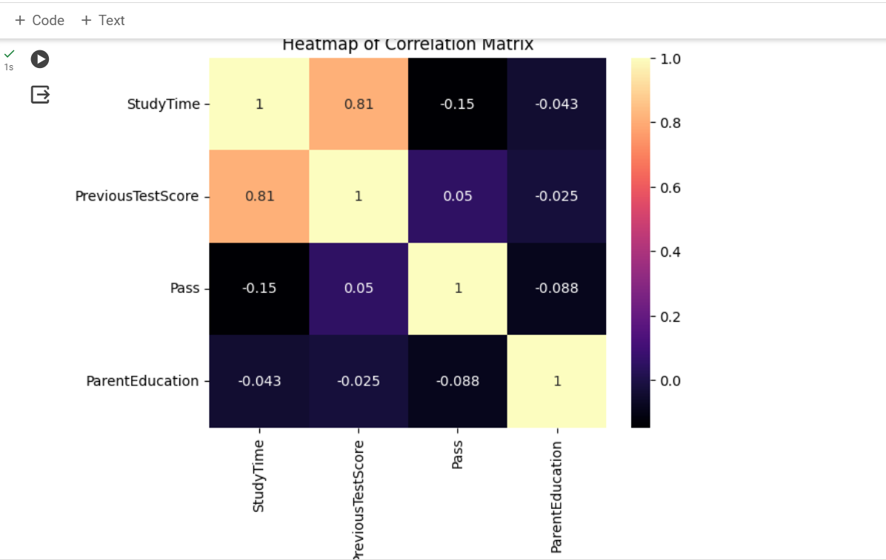

Bar plot for 'Log_Reg','Rand_Forest','KNN','XGBoost'

